

**IT1060 – Software Process Modeling May-2023**

# Assignment 2 Cover Sheet

|  |  |
| --- | --- |
| **CASE STUDY NAME** | Sign Up |
| **PROJECT ID** |  |

**Group Details:**

|  |  |  |
| --- | --- | --- |
|  | **Student Registration Number** | **Student Name** |
| **1** |  |  |
| **2** |  |  |
| **3** |  |  |
| **4** |  |  |
| **5** |  |  |

**IT1060 – Software Process Modeling**

# Assignment 2 Certify Sheet

|  |
| --- |
| **Checkmark with solid fill**I hereby certify,  **Checkmark with solid fill** The attached is my own work and no further changes will be made.  I have contributed in this assignment to the best of my ability.  And I understand,  **Checkmark with solid fill**I may be subject to student discipline processes in the event of an act of academic misconduct by me including an act of plagiarism or cheating. |

**Student Details:**

|  |  |  |  |
| --- | --- | --- | --- |
|  | **Student Registration** |  |  |
| **Student Name** | **Number** | **Date** | **Signature** |
| Afzal Ahamad. AH | IT22102782 | 29/05/2023 |  |

Part 1

|  |  |  |
| --- | --- | --- |
| **Use case ID** | OTT_L_1 | |
| **Use case Name** | Add video | |
| **Summary** | Adding previous lecture videos and links | |
| **Priority** | 1 | |
| **Preconditions** | Lecturer needs to sign in his or her account | |
| **Primary Actor(s)** | lecturer | |
| **Trigger** | Lecturer has chosen to train trainee teacher through their videos and links | |
| **Main Scenario** | **Step** | **Action** |
| **1** | Go to the Online Teacher Trainer page. |
| **2** | log in as lecturer |
| **3** | System check the Lecturer account details |
| **4** | Lecturer uploads the videos and tutorials |
| **5** | Lecturer can check the videos which are uploaded |
| **6** | Log out as lecture |
| **Extensions** | **Step** | **System Action** |
| **5a** | If There any issues on uploaded videos and link. Go to coordinator |

Activity Diagram Without Partitioning

Sub system.

Part 2

sub activity diagram.

Sub Activity diagram partitioning.

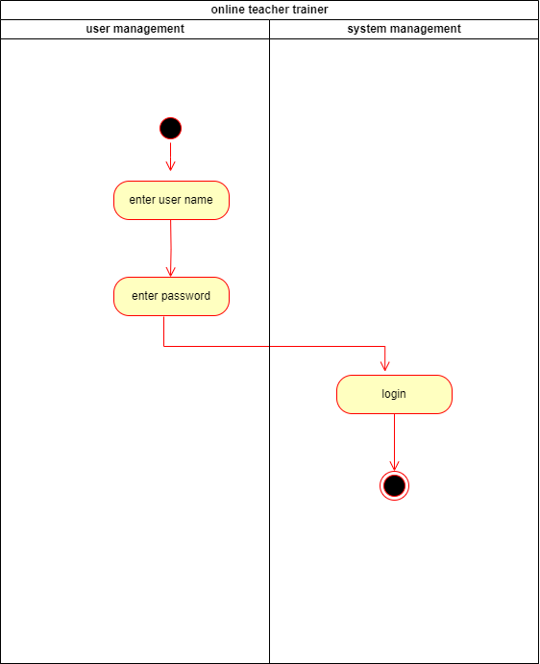

sub activity diagram partitioning.

